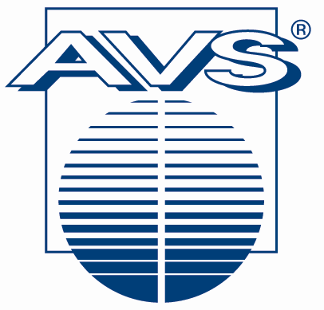
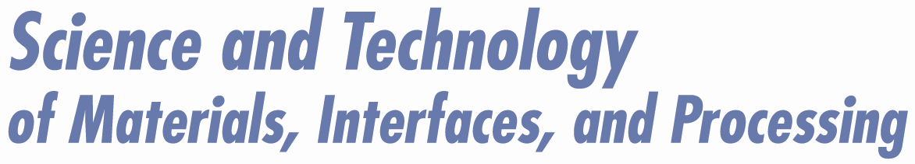

Topical Areas

Biomaterials

Environmental S&T

Magnetic Materials
Manufacturing S&T
Materials Characterization
Materials Processing

MEMS
Microelectronic Materials
Nanometer-Scale S&T
Plasma S&T
Surface Engineering
Surface Science
Thin Films

Vacuum Technology
Contacts
Managing Director
212-248-0200, ext. 222
Exhibition
212-248-0200, ext. 229
Finance
212-248-0200, ext. 224
Marketing/Meetings
530-896-0477
Member Services
212-248-0200, 221
Publications
919-361-2787
Short Courses
530-896-0477
Web/IT
212-248-0200, ext. 223
Officers
President
Angus A. Rockett
President-Elect
Alison A. Baski
Past-President
David G. Castner
Secretary
Joe Greene
Treasurer
Stephen M. Rossnagel
Directors
Jane P. Chang
Steven M. George
Luke Hinkle
Lars Hultman
Gregory Parsons
Susan B. Sinnott
AVS
125 Maiden Lane, 15th Floor
New York NY 10038
Phone: 212-248-0200
Fax: 212-248-0245
E-mail: avsnyc@avs.org
Web: www.avs.org

2010 End of Year Summary of AVS Hudson Mohawk Chapter

I wanted to send a fast message to our chapter members to recap our 2010 activities, and to wish everyone a safe and enjoyable holiday season.

The Hudson Mohawk Chapter of AVS hosted two meetings in 2010. A Spring meeting was held on 25 March 2010 at Rensselaer Polytechnic Institute (RPI) in Troy NY. The meeting started with six verbal talks – each had a (non-intentional) focus on “nano-technology”. The talks were followed by a poster session (with 19 submissions). See the url below for a list of abstracts:
http://www2.avs.org/chapters/hudsonmohawk/meetings.html

About 59 people attended the meeting, which provided for stimulating discussions. Gorun Butail, from RPI was the recipient of the best talk award ($200 gift card for Amazon) for her presentation “Voltage Controlled Branching of Titania Nanotubes and its Application for Photovoltaics”. Churamani Gaire, from RPI was the recipient of the best poster award ($150 gift card for Amazon) for his contribution “Quasi-Single Crystal Germanium Films on Biaxially Textured CaF2/glass substrates.

The fall meeting took place on 28 Oct 2010 at General Electric Global Research Center in Niskayuna NY. The meeting started with a short executive committee meeting which was followed by six verbal talks and 17 poster presentations. See the url below for a list of abstracts:
http://www2.avs.org/chapters/hudsonmohawk/pdf/Abstracts_2010fall.pdf

About 40 people attended the meeting, which provided for excellent scientific discussions. Peter K. B. Palomaki, from RPI, was the recipient of the best talk award ($200 gift card for Amazon) for his presentation “MAKING MOLECULAR MULTILAYERS USING “CLICK” CHEMISTRY: GROWTH AND THIN FILM CHARACTERIZATION”. Ben Backes, from College of Nanoscale Science and Technology, was the recipient of the best poster award ($150 gift card for Amazon) for his contribution “Modeling the Impact of COPPER PLASTICITY ON Thermo-Mechanical Stress Induced by Through-Silicon Vias (TSVs)”.

The 2011 officers will be:
•Chair: Alain Diebold, CNSE, University at Albany
•Chair Elect (2012 Chair): Ganpati Ramanath, RPI
•Past Chair: Vincent Smentkowski, GE-Global Research
•Secretary: Eric Bersch. CNSE, University at Albany
•Treasurer: J. “Scott” Price, GE-Global Research
•New Member-at-Large (2011)
➢Bill Sgammato – Thermo Fisher Scientific
➢Andrew C. Rudack - SEMATECH
- Each of the 2010 Members at Large will continue to serve.

We are also pleased to announce that our chapter members obtained recognition at the AVS 57th Annual Symposium and Exhibition:
1). Saurabh Garg, a graduate student from Rensselaer Polytechnic Institute (RPI) participated in the ASSD best presentation awards and won 2nd place for his presentation “Characterization of a Self-assembled Molecular Nanolayer at Buried Cu-silica Interfaces “! The first place award was granted to David Schmidt from the University of Nebraska-Lincoln for his presentation “Agent Free Bio-Chemical Sensing with Sculptured Thin Films” and the 3rd place award was provided to Michael Robinson from the University of Washington for his presentation “Sample Preparation of Cellular Samples for ToF-SIMS Analysis”. The ASSD had a large number of exceptional submissions which made judging difficult. We congratulate the ASSD best presentation award winners.

2). Lynn Gemmiti, an 11th and 12th grade NYS Regents level chemistry and physics teacher at Schalmont High School in Schenectady NY was selected to participate in the 2010 Science Educators’ Workshop in Albuquerque (sponsorship was provided by the AVS Hudson Mohawk Chapter ). The two day in service workshop was divided into two parts: (1) lectures on the underlying science and the mathematical calculations and (2) hands-on experience in which a group of teachers perform experiments and develop models under the guidance of an instructor team. See the photos of the demo’s (demo 1 , demo photo 2 ), talks (yes, teachers do take classes and notes see photo in class ), the Sun reception , and a photo of all participants and instructors (photo of attendees and instructors ). Upon completion of the workshop, the participating teachers receive at no cost: A certificate of completion, 1.4 Nationally certified CEU’s, and a vacuum system for their school to utilize (identical to ones used in the workshop). Lynn enjoyed participating in the workshop and looks forward to sharing her learnings with both students and other faculty member.

3). I was one of twelve people named a Fellow of AVS. My AVS Fellow citation reads: “For exceptional contributions in the field of industrial surface analysis, including multivariate statistical analysis of ToF-SIMS data”. Fellowship recognizes AVS members who have made sustained and outstanding scientific and technical contributions in areas of interest to AVS. This is the premier membership recognition for the AVS professional society. The award is capped annual at 0.5% of the total AVS membership.

2011 plans:
Our chapter is hosting the AVS and ASSD Topical Conference - Surface Analysis 2011 from April 11 – 13, 2011 at CNSE, University at Albany. For additional information, including meeting registration and the submission of abstracts see: https://www2.avs.org/divisions/assd/SurfaceAnalysis2011/default.html
An email blast went out to all AVS members on Friday Oct 29, 2011 with the first announcement and 1st call for papers. We hope to see all of our local chapter members at this meeting. If you are interested in helping at the meeting, please let me know, we can use help in many areas – this is a great opportunity for students. The Surface Analysis 2011 meeting will serve as our chapters Spring 2011 meeting.

I want to end this note by thanking both AVS National and all of our chapter members for their help in starting the new chapter. We are off to a very strong start and we have a great path forward. I enjoyed serving as 2009 and 2010 chair and I am certain that Alain Diebold (2011 Chair) and Ganpati Ramanath (2011 Chair Elect/2012 Chair) will help our chapter grow.

Best wishes for a Safe and Happy Holiday!

Vincent S. Smentkowski
Chair, Hudson Mohawk Chapter of AVS
Vincent_smentkowski@avs.org

