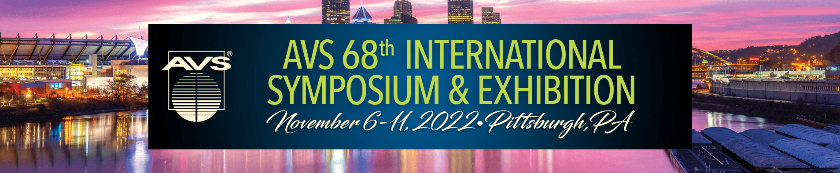
Trip Report Template for the
AVS International Symposium & Exhibition

Meeting: AVS 68th International Symposium and Exhibition
Dates: October 6-11, 2022
Location: David L. Lawrence Convention Center, Pittsburgh, PA, USA

The AVS International Symposium and Exhibition contains a packed, engaging, and diverse agenda of activities which takes throughout the week, including:
- Over 1300 technical presentations
  - 16+ parallel oral sessions run for five days;
  - Lively poster sessions on Tuesday and Thursday evenings
  - Post-meeting access to technical presentations online
- Practical Short Courses lasting from one to several days on a range of topics including surface analysis, fundamentals of vacuum technology, and thin film deposition
- An Exhibition with over 250 vendors which is open Tuesday through Thursday.
- Technology Spotlight presentations from Exhibitors
- Networking events including the Welcome Mixer, Poster Sessions, Awards Ceremony, and AVS Member Center professional development activities.
- Professional development activities including activities like Speed Networking, Job Information Forum, AVS Writers Workshop, Federal Funding Town Hall, and Work-Life Satisfaction Program
- Job Fair and Career Center connecting job seekers and potential employers
- Opportunities to attend the business meetings and become involved in leadership of AVS divisions and groups
- Opportunities to learn about and help develop standards and best practices, including ASTM E-42 committee on surface analysis
- Technical and leadership recognition, including an Awards Ceremony and Reception on Wednesday night.

Typical Symposium Registration Statistics (~2,500 Attendees)

The symposium contains parallel sessions assembled by the 10 AVS Divisions, 2 Groups, and 13 Focus Topics (see appendix A for a listing of the Divisions, Groups and Focus Topics).

Add a paragraph on how attendance helped your professional development and will benefit your company.

Highlights of key talks/posters attended
Topic 1-XXX
Talk title, speaker, notes
Talk title, speaker, notes
Talk title, speaker, notes
Talk title, speaker, notes

Topic 2-YYY
Talk title, speaker, notes
Talk title, speaker, notes
Talk title, speaker, notes
Talk title, speaker, notes

Users of the AVS Symposium Mobile App (which will launch early September 2022 will be able to:
- Use the schedule feature
- Add notes to each of the talks in their schedule and which they attended
- email all of the talk details to themselves
  - Below, we provide an example.
Event: MG-TuA1 Search for Substitutes of Critical Materials with Targeted Properties by Scale-Bridging and High-Throughput Modelling and Simulation
Date: Mon, Mar 2, 2022, 11:31 AM
Note: Great insight into alternatives for critical materials. Established contact to follow up on corporate concerns in this area.

Event: MG-WeM5 Manipulation of Site Reactivity at the Au Nanoparticle – Titania Interface through Alloying: Insights from Density Functional Theory
Date: Wed, Mar 18, 2022, 4:58 PM
Note: Approach may be useful to our new catalysis product thrusts.
The above details about the talks can be copied into this template!
(you may wish to delete the text above with yellow background before forwarding this report to your management team).

The full technical program and abstract book can be found on-line at: http://www.avs.org/symposium
Appendix A
AVS Divisions and Groups
- Advanced Surface Engineering
- Applied Surface Science
- Biomaterial Interfaces
- Electronic Materials & Photonics
- Magnetic Interfaces & Nanostructures
- Nanoscale Science & Technology
- Plasma Science & Technology
- Surface Science
- Thin Films
- Vacuum Technology
- Manufacturing Science & Technology
- MEMS and NEMS

Focus Topics at AVS 68 will feature state-of-the-art advances in…`
- 2D Materials
- Actinides and Rare Earths
- Advanced Ion Microscopy and Ion Beam Nano-Engineering
- Atomic Scale Processing
- Chemical Analysis And Imaging at Interfaces
- Fundamental Discoveries in Heterogeneous Catalysis
- Leaders in Energy and The Environment
- New Trends in Structural Electronic Characterization of Materials, Interfaces, and Surfaces Using Synchrotron and FEL Based Light Sources
- Quantum Information Science
- Radiation Effects on Materials
- Smart Multifuctional Materials for Nanomedicine
- Spectroscopic Ellipsometry
- Undergraduate Poster Session

